PIZZA SALES SQL QUERIES

1. **KPI’s**
2. **Total Revenue:**

SELECT SUM(total_price) AS Total_Revenue from [pizza_sales excel file.xlsx - pizza_sales]

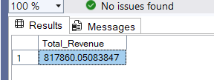

1. **Average Order Value:**

SELECT SUM(total_price)/COUNT(DISTINCT order_id) AS Avg_Order_Value from [pizza_sales excel file.xlsx - pizza_sales]

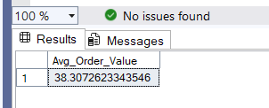

1. **Total Pizzas Sold:**

SELECT SUM(quantity) AS Total_Pizza_Sold from [pizza_sales excel file.xlsx - pizza_sales]

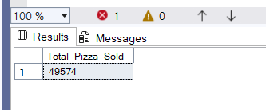

1. **Total Orders:**

SELECT COUNT(DISTINCT order_id) as Total_Orders from [pizza_sales excel file.xlsx - pizza_sales]

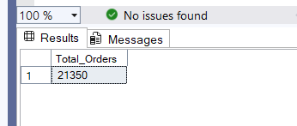

1. **Average Pizzas Per Order:**

SELECT CAST(CAST(SUM(quantity) AS decimal(10,2)) /

CAST(COUNT(DISTINCT order_id) AS decimal(10,2)) AS decimal(10,2))

AS Avg_Pizzas_Per_Order FROM [pizza_sales excel file.xlsx - pizza_sales]

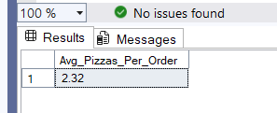

1. **Daily Trend for Total Orders:**

SELECT DATENAME(DW,order_date) as Order_day,Count(distinct order_id) as Total_Orders from [pizza_sales excel file.xlsx - pizza_sales]

group by DATENAME(DW,order_date)

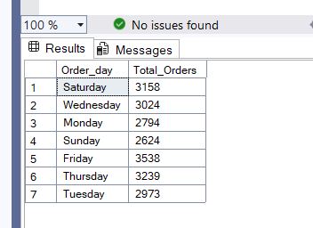

1. **Hourly Trend for Orders:**

SELECT DATEPART(Hour,order_time) AS Order_Hours,Count(Distinct order_id) as Total_Orders

from [pizza_sales excel file.xlsx - pizza_sales]

group by DATEPART(Hour,order_time)

order by DATEPART(Hour,order_time)

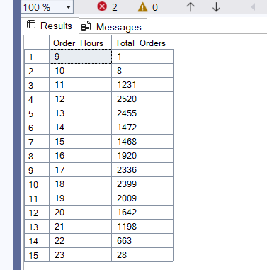

1. **% of Sales by Pizza Category:**

SELECT pizza_category,sum(total_price) as Total_Sales,sum(total_price) * 100/

(SELECT SUM(total_price) FROM [pizza_sales excel file.xlsx - pizza_sales] WHERE MONTH(order_date)=1) as PCT

from [pizza_sales excel file.xlsx - pizza_sales]

WHERE MONTH(order_date)=1

Group by pizza_category

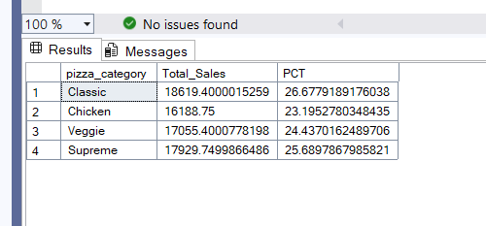

1. **% of Sales by Pizza Size:**

SELECT pizza_size,cast(sum(total_price) as decimal(10,2)) as Total_Sales,CAST(sum(total_price) * 100/

(SELECT SUM(total_price) FROM [pizza_sales excel file.xlsx - pizza_sales] WHERE DATEPART(QUARTER,order_date)=1) AS decimal(10,2)) as PCT

from [pizza_sales excel file.xlsx - pizza_sales]

WHERE DATEPART(QUARTER,order_date)=1

Group by pizza_size

ORDER BY PCT DESC

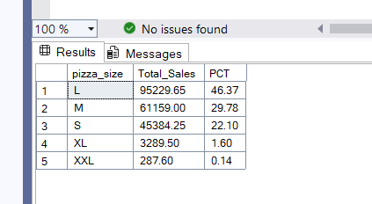

1. **Total Pizzas Sold by Pizza Category:**

SELECT pizza_category,SUM(quantity) as Total_Quantity_Sold from [pizza_sales excel file.xlsx - pizza_sales]

group by pizza_category

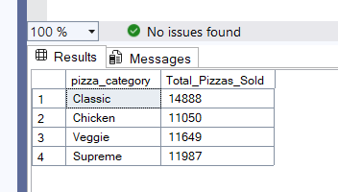

1. **Top 5 Best Sellers by Total Pizzas Sold:**

SELECT TOP 5 pizza_name,sum(quantity) as Total_Pizza_sold

from [pizza_sales excel file.xlsx - pizza_sales]

group by pizza_name

order by Total_Pizza_sold DESC

